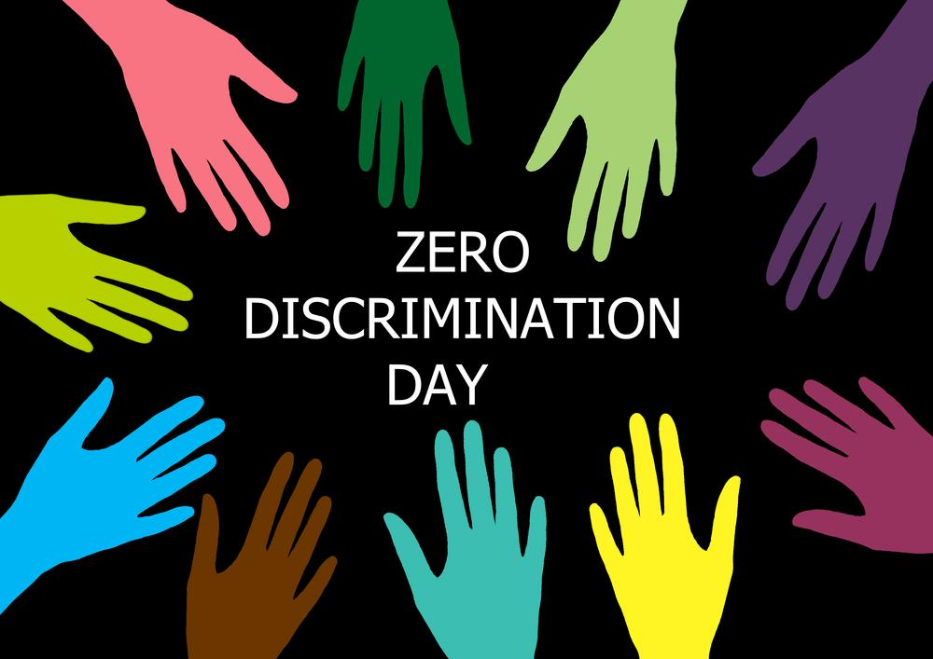

***March 1 is marked as Zero Discrimination Day. What it means for the global HIV/AIDS community and the rest of the world?***

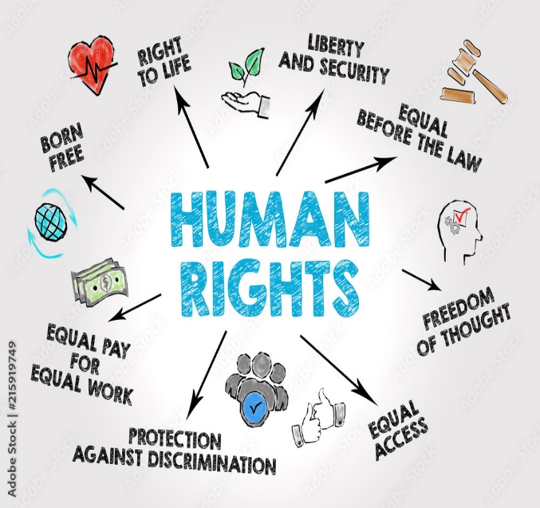

*“Health services in the hospital was good, however the behaviour of the health workers was not that good”. After the hospital officials knew that I was HIV infected, they discharged me earlier than expected.” Male, Kathmandu*

***Zero Discrimination Day***

*Discrimination continues to affect the lives of millions of people around the world. Millions of women and girls in every region of the world experience violence and abuse and are unable to exercise their rights or gain access to health-care services, education or employment. Discrimination at work, school, healthcare and other settings reduces people’s ability to participate fully and meaningfully in societies and provide and care for themselves and their families. Many countries have laws*

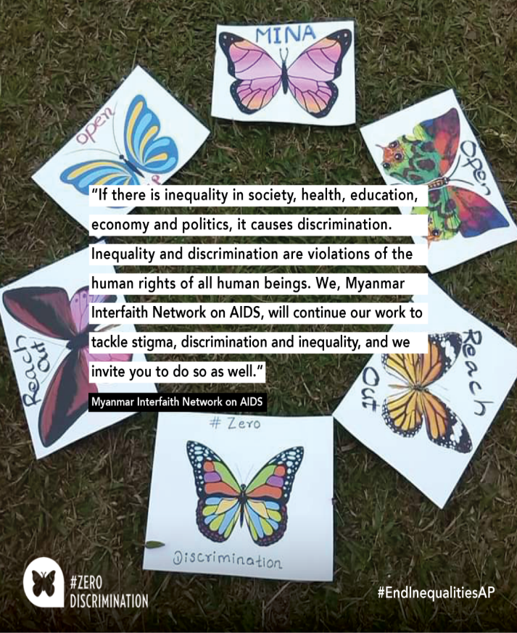

*against discrimination but it is still a problem in all layers of society globally.*

*Discrimination is illegal, immoral, hurtful and dehumanizing. Too many people around the world face unequal treatment because of*

*their race, religion, nationality, sexual orientation or identity, disability, gender or age****.*** *Discrimination can happen anywhere: at work, at school, at home and in the community****. Discrimination does not just hurt individuals or groups of people, it hurts everyone. To*** *counter discrimination and encourage acceptance several activities can be conducted such as speaking up when something is wrong; raising awareness; supporting people who have been discriminated against; and promoting the benefits of diversity. On March 1, Zero Discrimination day is celebrated where people from all corners of the world unite under the theme of “Open Up, Reach Out” in order to celebrate diversity and reject discrimination in all its forms. The Zero Discrimination Day is a UNAIDS campaign of solidarity that stands up to racism and discrimination. The UN first celebrated Zero Discrimination Day on March 1, 2014, after UNAIDS, a UN programme on human immunodeficiency virus (HIV) and Acquired Immune Deficiency Syndrome (AIDS), launched its Zero Discrimination Campaign on World AIDS Day in December 2013. Butterfly is a symbol for Zero Discrimination Day, widely used by people to share their stories and photos as a way to end discrimination and work towards positive transformation. In 2013, UNAIDS estimated that 35 million people globally were living with HIV, while 2.1 million people became newly infected with the virus and 1.5 million people died from AIDS-related illnesses.*

**

*there are almost 80 countries that still have laws criminalizing same-sex sexual relations. Some 38 countries, territories and areas impose some form of restriction on the entry, stay and residence of people living with HIV. Furthermore, legal and social environments* *have not been conducive enough to address stigma and discrimination against people living with and those most vulnerable to HIV infection.*

*Unaids*  *has a vision of zero new HIV infections, zero discrimination and zero AIDS-related deaths. Without achieving zero discrimination, it will be impossible to bring down to zero new HIV infections or zero AIDS-related deaths. According to Ban Ki-Moon, “Discrimination is a violation of human rights and must not go unchallenged and everyone has the right to live with respect and dignity.” It is believed that some of the most challenging problems of the world can be simply solved by eliminating discrimination and stigma. Zero Discrimination Day draws attention to the millions who still suffer from social and economic exclusion due to prejudice and intolerance. Millions of women and girls in every region of the world who experience violence and abuse on a daily basis and struggle to access adequate health*

*care and education can be supported by the Zero Discrimination Campaign. HERD’s Study among PLHIV*

***HERD’s Study among PLHIV***

*HERD conducted a qualitative research study (December 2012-December 2015) in collaboration with University of Edinburgh, UK. This research study aimed to generate understanding around problems faced by people with TB/HIV co-infection and how they deal with it. The study used Participatory Ethnographic Evaluation and Research (PEER) ethnography and semi structured interview methods for data collection. This study was funded by Wellcome Trust and was implemented with support from National Association of People Living with HIV and Aids (NAP+N). People Living with HIV and AIDS were approached using NAP+N network. Likewise, two researchers from NAP+N were recruited and trained for data collection.*

**

*This study examined how People living with HIV and AIDS (PLHIV) conceptualize stigma and society as experienced discrimination. It explored various manifestations of stigma and discrimination at different levels throughout by PLHIV.*